**CURRICULUM VITAE**

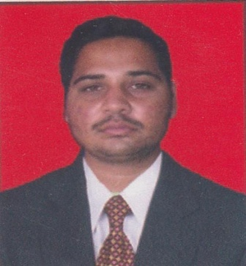

**DINESH KUMAR MAHAPATRA**

**C/O :PRAKASH KUMAR MAHAPATRA**

**AT/PO : SUBARNAPUR**

**PS: BANKI**

**VIA: ATHAGARH**

**DIST : CUTTACK**

**ODISHA - 754029**

**MOBILE :8763939113**

**Email ID:dineshmahapatra95@gmail.com**

**Career Objective**

To work in an organization where, I am able to contribute the organization’s growth and profitability with my skills and taking challenges working hard, in a term and cooperate with all the members in the organization.

**Academic Qualification**

|  |  |  |  |  |  |  |
| --- | --- | --- | --- | --- | --- | --- |
| **Degree/ Course** | **University / Board** | **Year of Passing** | **Total Marks** | **Mark Secure** | **Percentage** | **Division** |
| Matriculation | Board of Secondary Education , Odisha | 2010 | 600 | 370 | 61.66% | 1st |
| +2 Commerce | CHSE, Odisha | 2012 | 600 | 370 | 61.66% | 1st |
| B.Com (Hons) | Utkal University, Odisha | 2015 | 1800 | 1103 | 61.27% | 1st |

**Computer Proficiency :**

* Windows, MS Office 2010, Tally ERP 9, PGDCA
* Internet & Email, etc.

**Strengths**

* Work with positive attitude to contribute the healthy functioning of the organisation .
* Self confidence and great patience
* Vibrant, Dynamic, efficient and a go- getter.

Work experience

Five Months working at ICICI BANK Sales officer (current account connected banking)

**Hobbies**

* Reading News Paper & Book.
* Making friends.
* Travelling
* Watching News channels.

**Personal Profile**

**Name**  : **Dinesh Kumar Mahapatra**

Father’s name : **Prakash Kumar Mahapatra**

Mother’s name : Malaya Manjari Mahapatra

Date of Birth : 15th May 1995

Gender : Male

Category : OBC

Religion : Hindu

Marital Status : Unmarried

Nationality : Indian

Language Known : English, Hindi & Odia

**Permanent Address:**

**At/Po : Subarnapur**

**PS: Banki**

**Via: Athagarh**

**Dist : Cuttack,**

**State :Odisha – Pin: 754029**

**Declaration**

I hereby declare that the information furnished above is true to the best of my knowledge & belief.

**Place : BHUBANESWAR**

**Date :18/10/2019 (DINESH KUMAR MAHAPATRA)**

***Signature***